Hotel MRAK  Rimska cesta 4, Ljubljana  Tel. no.: +386 1 42 19 600  Fax: +386 1 42 19 655  E-mail: info@hotelmrak.si  http://www.hotelmrak.si | 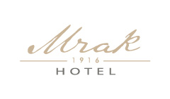

HOTEL MRAK REGISTRATION FORM

Name and surname: ____________________________

Arrival date: ___

Departure date: ____

Number of persons: _______

Room type booking;
□ X Double room for single use € 90
□ X Double or twin room €115

Please specify the room type and required number of rooms.

Payment method: (credit card (VISA, AMEX, EC-MC), cash) _____________________

Please note: Payment is possible by cash or credit card. In any case, please provide your credit card number, expiry date and verification code for reservation guarantee.

Parking place in the vicinity of hotel: 16,00 EUR/24 hour YES NO

Transfer from airport to hotel: 35,00 €/person or 50€ both ways YES NO

Shuttle 11€ per person if there are two persons or more YES NO

Please specify the airport arrival time _________ and your flight number_____________

Date of reservation: __________________ Signature: ____________________

WE GUARANTEE THESE PRICES UNTIL …………30.4.2018…………….

Bookings are also accepted by e-mail: sales@hotelmrak.si reserve with code ___IFIP 2018___

